Basic Information

Procurement Title | Procurement of Visibility materials including  Signboards ,T-shirts,Caps  Including Transportation and Delivery outside of Monrovia
Atlas e-Requisition # | 0000005189
Advertisement Period | 5 business days.  (minimum of 5 business days for RFQ)
Nature of Tender | Competitive Process
Deadline for Submitting Clarification Questions | 2 days before deadline for responses.
Quotation Validity Period | 30
Requesting Unit/Office/Country/Region | WPS/LIBERIA/WCARO
Value Added Tax in Financial Proposal | Must be exclusive of VAT and other applicable indirect taxes
Expected Delivery Date and Time | ☒ Expected delivery/completion date: 26.11.2021  ☐ As per Delivery Schedule attached
Advance payment | Not Allowed  If allowed, Bank Guarantee Not required
Liquidated Damages | Will not be imposed  Percentage of contract price per week of delay: 3% up to a maximum of 10% of the Contract value, after which UN Women may terminate the contract.
Partial quotations (lots) | Partial quotations shall not be allowed. Vendors must quote prices for the total requirement requested under Schedule of Requirements. Evaluation will be done for the total requirement.
Alternative quotations | Shall not be considered.
Quotations currencies | Prices shall be quoted in United States Dollars
Contract award to one or more vendor | UN Women will award a contract to:  One or more Vendors, depending on the following factors: [Availability of all requested items within the desired price range]
Other information related to the RFQ

STATEMENT OF NEED:

UN Women on the joint project ‘Sustaining Peace and Reconciliation through Strengthening Land Governance and Dispute Resolution Mechanisms’ is responsible for ensuring project visibility within all our project target communities. The WPS team has agreed to support with the procurement of some of the visibility materials by procuring sign boards for 33 of the 43 project communities and T-shirts and Caps for partners and community representatives. Adjacent communities will share sign board making the total number of sign boards 29.Tshirts and Caps will both be 1000 pcs as per requiremnts listed below .

Technical Specifications for Goods:

Item No | Minimum Technical Requirements | Unit | Quantity
1. | Community Sign Boards  Labelled sign board with dimensions 5”x 4” (L/W)  Nimba County  Community Names; 16 communities  Flumpa Korsein Garrblein  Gbayblain New Yekepa Gbayee  Yarsonnor Camp4 Torkopa  Gipo Gbapa, Makinto  Mehnpa Garryehbo  Sehye-geh Zolowee.  Total No. Of Sign Boards – 16  Grand Cape Mount County – 17 Communities  Community Names:  Gbah – Foboi Mesila Damah  Madina Falie Gohn  Meekor Konjah Karnga  Soe Timbo Lainn  Senii Daindeiweah Gbunajah  Kaylia JohnsonJah  Shared Sign Boards -3  - Gohn,Falie,and Karnga  - Madina and Meekor  - Kaylia and Konjah  Total No. of Sign Boards – 13  Grand Total 13 + 16 = 29 Sign boards  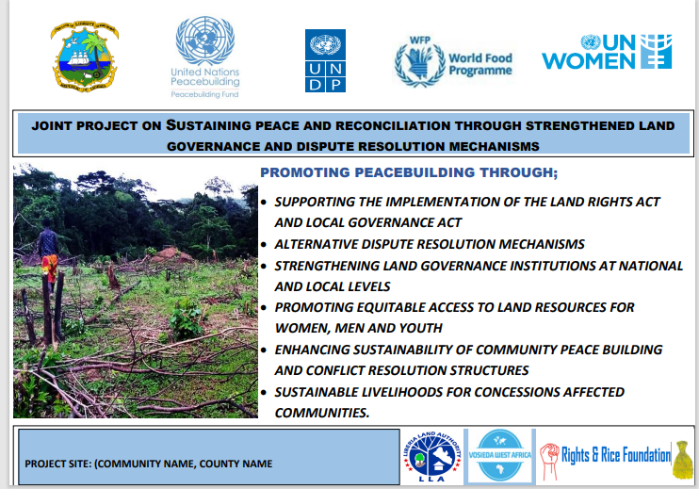 | Sign Boards | 29
2 | T- shirts  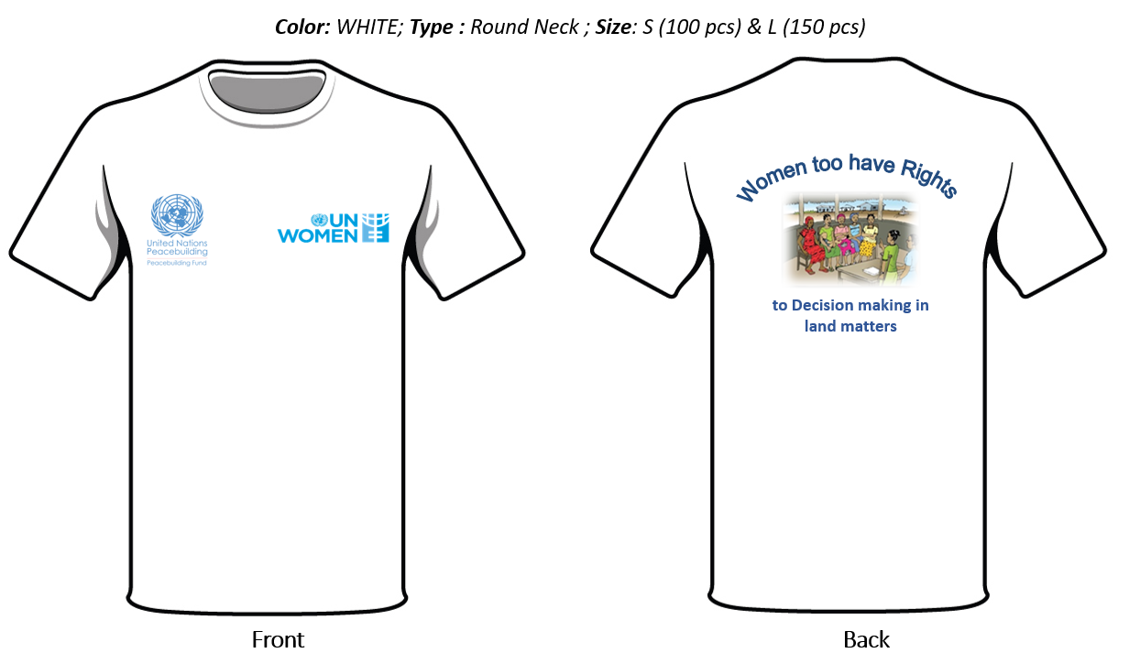  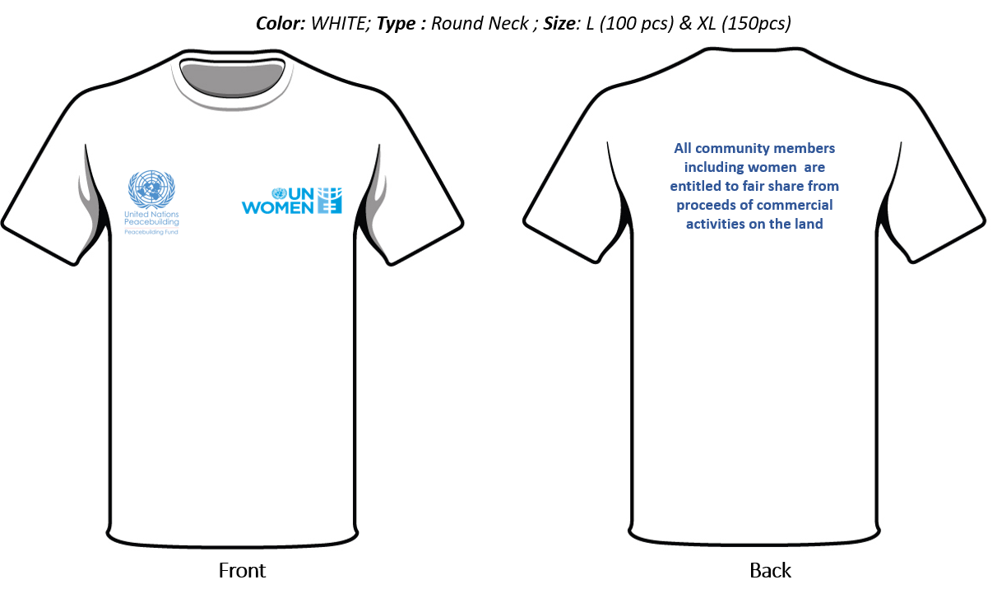  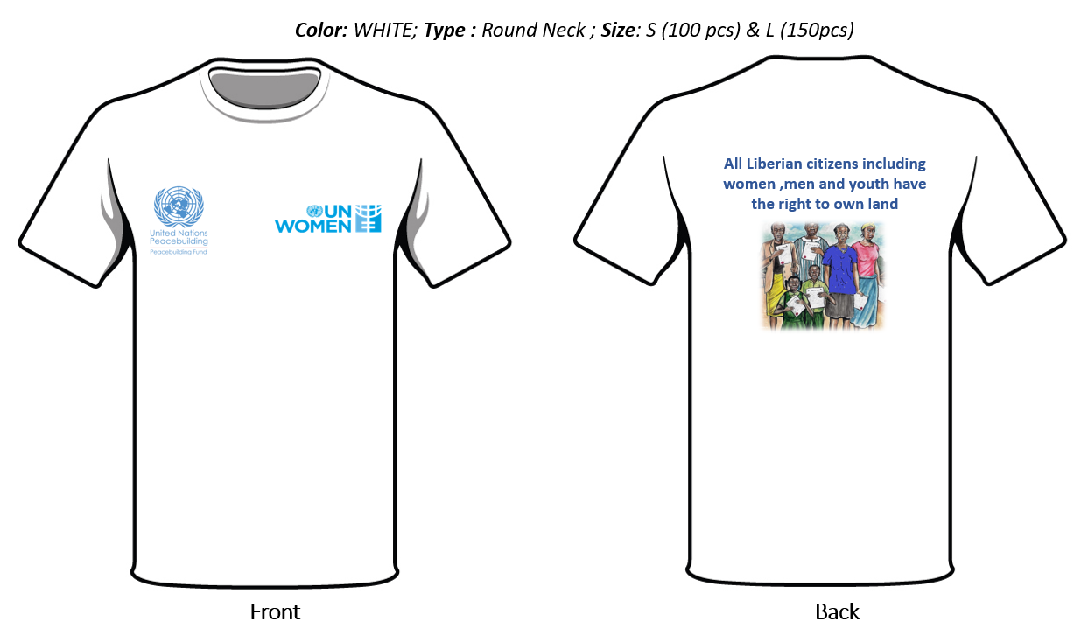  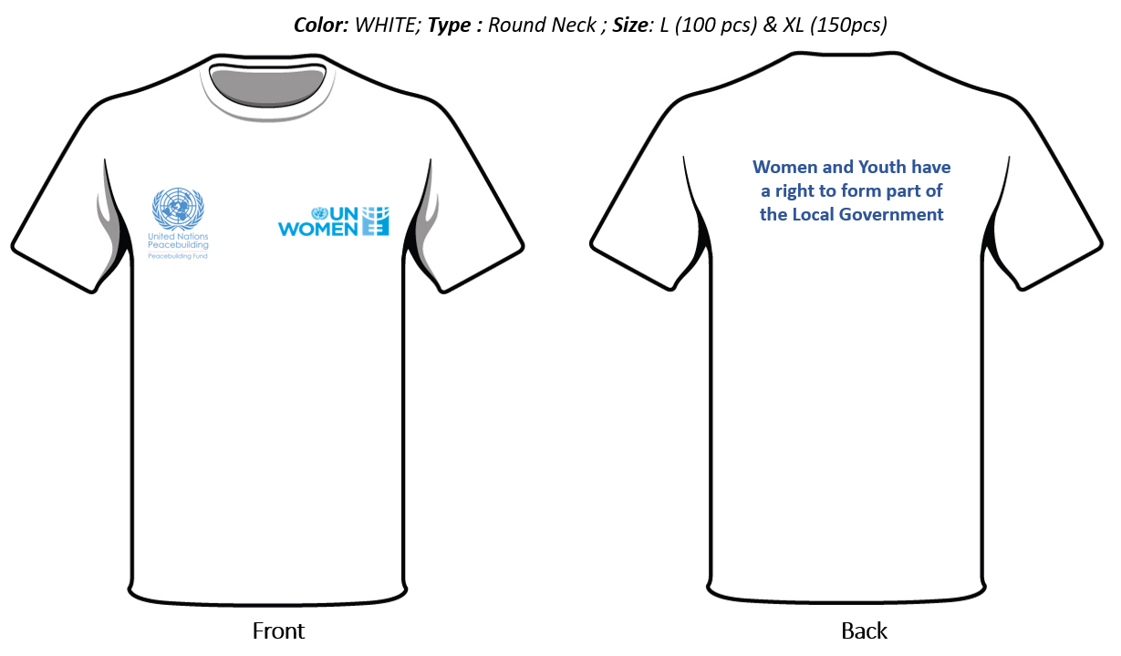 | Tshirts | 1000
3 | Caps  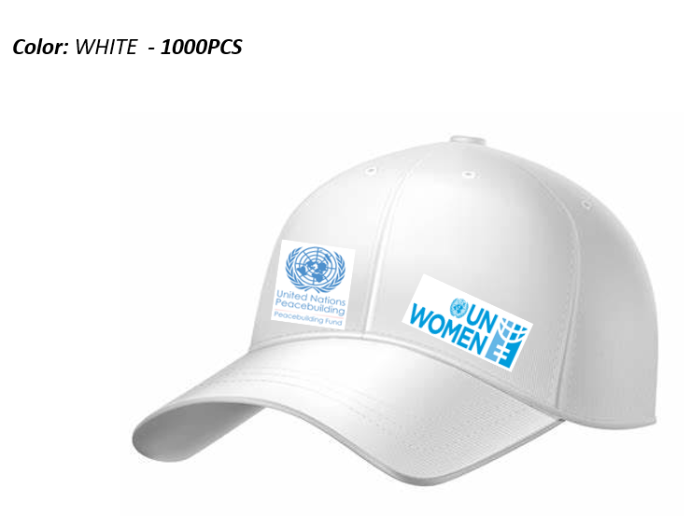 | Caps | 1000
Delivery:

- T-shirts and Caps delivery to Rights and Rice foundation office

- Signboards to be delivered to Nimba and Grand Cape Mount Counties

Delivery Requirements
Delivery Requirements
Delivery date and time | Vendor shall deliver the goods one Week after Contract signature.
Delivery Terms (INCOTERMS 2020) | 2-3 WEEKS
Customs clearance  (must be linked to INCOTERM) | ☐ Not applicable  Shall be done by:  ☐ Name of organisation  ☒ Vendor/bidder  ☐ Freight Forwarder
Exact Address(es) of Delivery Location(s) | Att. Georgette Dennis  UN Women  Room 302A PAP Building  1st Street, Tubman Boulevard  Monrovia, Liberia  Tel: 231 770 -163267  Email: georgette.dennis@unwomen.org
Distribution of shipping documents (if using freight forwarder) | YES
Special Packing Requirements | N/A
Training on Operations and Maintenance | N/A
Warranty Period | 2 YRS
After-sales service and local service support requirements | YES
Preferred Mode of Transport | Air
Subcontracting | The vendor is strongly encouraged not to sub-contract > 50% of the total work. If a vendor/s intend to do so, they must state the actual percentage (that will be outsourced) in their offer/quotation.

Inspections and tests
The following inspections and tests shall be performed:

If the goods fail to meet the laid down specifications, the vendor shall take immediate steps to remedy the deficiency or replace the defective goods to the satisfaction of UN Women.

Technical and Financial Offer
Vendors are requested to complete this form, sign it and return it as part of their quotation. The Vendor shall fill in this form in accordance with the instructions indicated. No alterations to its format shall be permitted and no substitutions shall be accepted. Instructions on inclusion of VAT and other direct/indirect taxes are included in the solicitation documents and shall be followed when preparing the financial proposal.

Name of Vendor: | Click or tap here to enter text.
RFQ reference: | Click or tap here to enter text. | Date: Click or tap to enter a date.

Currency of the Quotation: Click or tap here to enter text.
INCOTERMS: Click or tap here to enter text.
Item No | Description | UOM | Qty | Unit price | Total price
1. | Click or tap here to enter text.
2. | Click or tap here to enter text.
3. | Click or tap here to enter text.
4. | Click or tap here to enter text.
5. | Click or tap here to enter text.
Total Price
Transportation Price
Insurance Price
Installation Price
Training Price
Other Charges (specify)
Total Final and All-inclusive Price
Note: In case of discrepancy between unit price and total, the unit price shall prevail.
Compliance with Requirements

Requirement | Your Responses
 | Yes, we will comply | No, we cannot comply | If you cannot comply, pls. indicate counter proposal
Minimum Technical Specifications | ☐ | ☐ | Click or tap here to enter text.
Delivery Term (INCOTERMS) | ☐ | ☐ | Click or tap here to enter text.
Delivery Lead Time | ☐ | ☐ | Click or tap here to enter text.
Warranty and After-Sales Requirements | ☐ | ☐ | Click or tap here to enter text.
Validity of Quotation | ☐ | ☐ | Click or tap here to enter text.
Payment terms | ☐ | ☐ | Click or tap here to enter text.
Other requirements [pls. specify or remove] | ☐ | ☐ | Click or tap here to enter text.

Other Information:

Estimated weight/volume/dimension of the Consignment: | Click or tap here to enter text.
Country/ies of Origin:  (if export licence required this must be submitted if awarded the contract) | Click or tap here to enter text.

I, the undersigned, certify that I am duly authorized to sign this quotation and bind the company below in event that the quotation is accepted.

Company Name: | Click or tap here to enter text. | Authorized Signature:
Address: | Click or tap here to enter text. | Date: | Click or tap here to enter text.
Phone No.: | Click or tap here to enter text. | Functional title of Authorized Signatory: | Click or tap here to enter text.
E-mail address: | Click or tap here to enter text. | E-mail address: | Click or tap here to enter text.

The decision on inclusion of VAT and any other taxes in financial proposals shall be based on the local legislation and SBAA agreement with the host country/-ies of the relevant Office ordering or performing the payment for the services. Depending on host countries, UN Women may be exempt from payment of direct and indirect taxes or may be required to pay the taxes and request reimbursement by submitting tax invoices.

