Section II: Schedule of Requirements

ESourcing reference: RFQ/2022/43702

Technical specifications for Goods and Comparative Data Table:

Name of Bidder: [insert name of Bidder]

Bidders are required to complete the Comparative Data Tables included in Section II: Schedule of Requirements to demonstrate compliance with UNOPS requirements and insert them below. Bidders are NOT allowed to make any change in the “UNOPS requirements” columns of the Comparative Data Tables. Such changes might disqualify your quotation.
Although some pictures have been included, this is for the purpose of samples only.
Technical specifications for goods – Comparative Data Table

Item No | UNOPS minimum technical requirements | Quantity | Is bid compliant? Bidder to complete | Details of goods offered. Bidder to complete  Bidders must provide details against each specification. to confirm that they qualify for each of the criteria. YES or NO answers are NOT acceptable

1 | No smoking sign | 18 |  | Insert detailed specifications of goods offered
 | Sign must be mounted on a plastic or acrylic sheet (3mm thickness minimum) with a white background  (acceptable variance of -/+10%) |  |  | Insert detailed specifications of goods offered
 | Must be wall mountable |  |  | Insert detailed specifications of goods offered
 | Size: Minimum 6” x 6” |  |  | Insert detailed specifications of goods offered
 | Internationally recognised sign for no smoking. |  |  | Insert detailed specifications of goods offered
 | Brochures / Catalogues/ Specification sheet Must be Attached complete with Brand/ Model details/product specifications as applicable |  |  | To be provided
 | Picture For reference:
2 | Danger corrosive material sign | 6 |  | Insert detailed specifications of goods offered
 | Sign must read: Danger Corrosive Materials - Wear personal protective equipment. |  |  | Insert detailed specifications of goods offered
 | Mounted on rigid plastic/acrylic (3mm thickness minimum)  (acceptable variance of -/+10%) |  |  | Insert detailed specifications of goods offered
 | Wall mountable |  |  | Insert detailed specifications of goods offered
 | Size: Approx. 300mm (L) x 200mm (H)  (acceptable variance of -/+10%) |  |  | Insert detailed specifications of goods offered
 | Brochures / Catalogues/ Specification sheet Must be Attached complete with Brand/Model details/product specifications as applicable |  |  | To be provided
 | Picture For reference: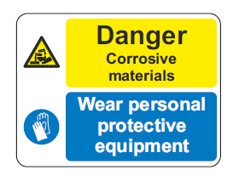
3 | Flammable material sign | 6 |  | Insert detailed specifications of goods offered
 | Sign must read: Danger flammable liquid - No smoking - No naked lights. |  |  | Insert detailed specifications of goods offered
 | Mounted on rigid plastic (3mm minimum thickness)  (acceptable variance of -/+10%) |  |  | Insert detailed specifications of goods offered
 | Wall mountable |  |  | Insert detailed specifications of goods offered
 | Size: Approx. 300mm (L) x 200mm (H)  (acceptable variance of -/+10%) |  |  | Insert detailed specifications of goods offered
 | Brochures / Catalogues Must be Attached complete with Brand and Model details |  |  | To be provided
 | Picture For reference: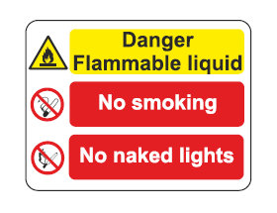
4 | Breathing apparatus mandatory sign | 12 |  | Insert detailed specifications of goods offered
 | Size: 300mm x 300mm |  |  | Insert detailed specifications of goods offered
 | Material: Aluminium or plastic (3mm thickness minimum) |  |  | Insert detailed specifications of goods offered
 | Wall mountable |  |  | Insert detailed specifications of goods offered
 | Brochures / Catalogues/ Specification sheet Must be Attached complete with Brand/Model details/product specifications as applicable |  |  | To be provided
 | Picture For reference: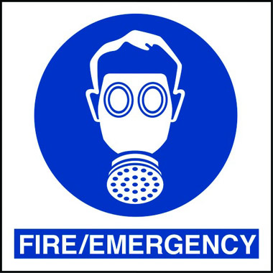
5 | Eye protection must be worn sign | 6 |  | Insert detailed specifications of goods offered
 | - Mounted on rigid plastic (3mm thickness minimum)  (acceptable variance of -/+10%) |  |  | Insert detailed specifications of goods offered
 | - Size: Approx. 300mm (L) x 100mm (H)  (acceptable variance of -/+10%) |  |  | Insert detailed specifications of goods offered
 | - Wall mountable |  |  | Insert detailed specifications of goods offered
 | - No corrosive parts |  |  | Insert detailed specifications of goods offered
 | Brochures / Catalogues/ Specification sheet Must be Attached complete with Brand/Model details/product specifications as applicable |  |  | To be provided
 | Picture For reference:
6 | First aid point sign | 12 |  | Insert detailed specifications of goods offered
 | Mounted on rigid plastic (3mm minimum thickness)  (acceptable variance of -/+10%) |  |  | Insert detailed specifications of goods offered
 | Size: Approx. 300mm (L) x 100mm (H)(acceptable variance of -/+10%) |  |  | Insert detailed specifications of goods offered
 | Wall mountable |  |  | Insert detailed specifications of goods offered
 | No corrosive parts |  |  | Insert detailed specifications of goods offered
 | Brochures / Catalogues/ Specification sheet Must be Attached complete with Brand/Model details/product specifications as applicable |  |  | To be provided
 | Picture For reference: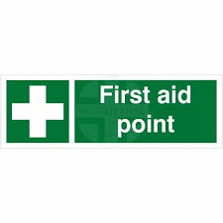
7 | No parking loading and unloading only sign | 12 |  | Insert detailed specifications of goods offered
 | - Mounted on rigid plastic (Minimum thickness 3mm)  (acceptable variance of -/+10%) |  |  | Insert detailed specifications of goods offered
 | - Size: Approx. 400mm (L) x 300mm (H)  (acceptable variance of -/+10%) |  |  | Insert detailed specifications of goods offered
 | - Wall mountable |  |  | Insert detailed specifications of goods offered
 | - No corrosive parts |  |  | Insert detailed specifications of goods offered
 | Brochures / Catalogues/ Specification sheet Must be Attached complete with Brand/Model details/product specifications as applicable |  |  | To be provided
 | Picture For reference: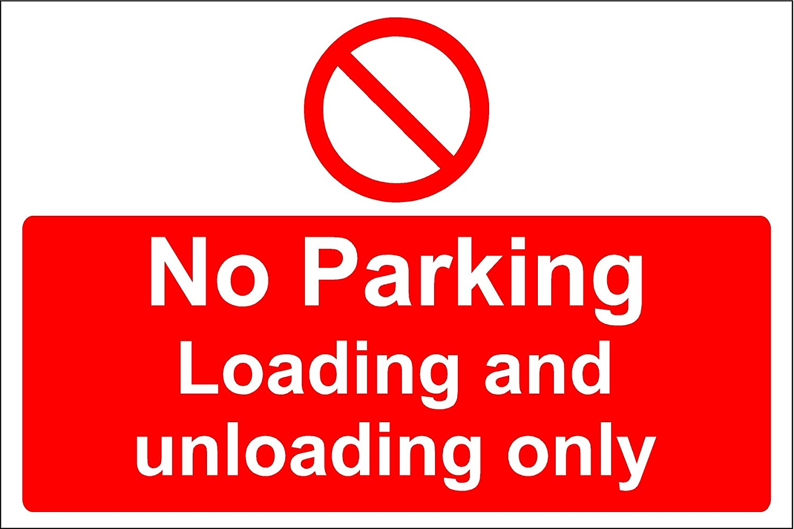
8 | Fire division sign | 6 |  | Insert detailed specifications of goods offered
 | Fire division 4 placard |  |  | Insert detailed specifications of goods offered
 | Reflective |  |  | Insert detailed specifications of goods offered
 | Shape: Diamond |  |  | Insert detailed specifications of goods offered
 | Size: 12” |  |  | Insert detailed specifications of goods offered
 | Colour: Black border, orange background, black number 4 |  |  | Insert detailed specifications of goods offered
 | Mounted on rigid plastic (Minimum thickness 3mm)(acceptable variance of -/+10%) |  |  | Insert detailed specifications of goods offered
 | Wall mountable |  |  | Insert detailed specifications of goods offered
 | No corrosive parts |  |  | Insert detailed specifications of goods offered
 | Brochures / Catalogues/ Specification sheet Must be Attached complete with Brand/Model details/product specifications as applicable |  |  | To be provided
 | Picture For reference:
9 | Class 3 hazardous goods label | 12 rolls |  | Insert detailed specifications of goods offered
 | Class 3 flammable liquid sticker |  |  | Insert detailed specifications of goods offered
 | Self adhesive |  |  | Insert detailed specifications of goods offered
 | Rolls of 150 labels each |  |  | Insert detailed specifications of goods offered
 | Dimensions: 100mm x 100mm |  |  | Insert detailed specifications of goods offered
 | Background colour red |  |  | Insert detailed specifications of goods offered
 | Markings: English |  |  | Insert detailed specifications of goods offered
 | Material: Polypropylene or equivalent |  |  | Insert detailed specifications of goods offered
 | Conforms to BS 5609 or equivalent |  |  | Insert detailed specifications of goods offered
 | Brochures / Catalogues/ Specification sheet Must be Attached complete with Brand/Model details/product specifications as applicable |  |  | To be provided
 | Picture For reference: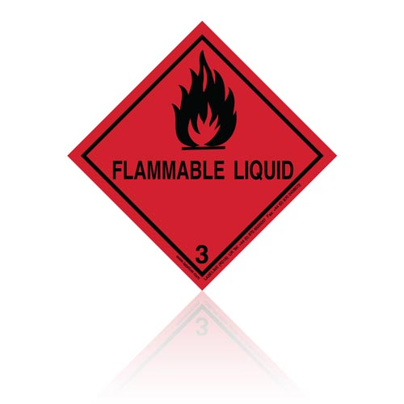
10 | Class 8 hazardous goods label | 12 rolls |  | Insert detailed specifications of goods offered
 | Class 8 corrosive substance sticker |  |  | Insert detailed specifications of goods offered
 | Self adhesive |  |  | Insert detailed specifications of goods offered
 | Rolls of 150 labels each |  |  | Insert detailed specifications of goods offered
 | Dimensions: 100mm x 100mm |  |  | Insert detailed specifications of goods offered
 | Background: Black and white |  |  | Insert detailed specifications of goods offered
 | Markings: English |  |  | Insert detailed specifications of goods offered
 | Material: Polypropylene or equivalent |  |  | Insert detailed specifications of goods offered
 | Conforms to BS 5609 or equivalent |  |  | Insert detailed specifications of goods offered
 | Brochures / Catalogues/ Specification sheet Must be Attached complete with Brand/Model details/product specifications as applicable |  |  | To be provided
 | Picture For reference:

11 | Contraband Notice | 6 |  | Insert detailed specifications of goods offered
 | Material: Plastic/Perspex/Acrylic or Aluminium is preferred. Material should be corrosion resistant. |  |  | Insert detailed specifications of goods offered
 | Size: 1000mm x 600mm |  |  | Insert detailed specifications of goods offered
 | Pre-drilled for mounting |  |  | Insert detailed specifications of goods offered
 | Wall mountable |  |  | Insert detailed specifications of goods offered
 | Durable UV resistant ink |  |  | Insert detailed specifications of goods offered
 | (Artwork Attached in Annex 1 to the RFQ)

Delivery requirements –– Comparative Data Table

UNOPS Requirements |  | Is quotation compliant? Bidder to complete | Details  Bidder to complete
Sustainability criterion | Supplier’s Commitment to sustainability - Bidder must provide at least one of the following: • Documentation confirming the presence of a valid Environmental Management System such as ISO 14001 or equivalent • A copy of the organisation’s sustainability policy • A copy of the organisation’s latest corporate social responsibility report • A copy of the organisation’s most recent UN Global Compact Communication on Progress report • A signed statement from the President (or other executive officer) | ☐ Yes ☐ No | Insert details
Delivery time | Bidder shall deliver the goods 4-6 weeks after contract signature. | ☐ Yes ☐ No | Insert details
Delivery place and Incoterms rules | CPT (Incoterm 2010), Aden Abdulle International Airport (AAIA).  Mogadishu, Somalia | ☐ Yes ☐ No | Insert details
Consignee details | UNMAS Somalia  UNSOS/UNSOM Compound  Aden Abdulle International Airport (AAIA)  Mogadishu, Somalia  Contact: Mr husseinali@unops.org  husseinali@unops.org  Tel: +252619615325 | ☐ Yes ☐ No | Insert details
UNOPS Right to vary requirements | At the time the Contract is awarded, UNOPS reserves the right to vary the quantity of the goods and associated services specified above, provided this does not exceed +/- 20%, without any change in the unit prices or other terms and conditions of the RFQ. | ☐ Yes ☐ No | Insert details

