

INDIVIDUAL CONTRACT (IC)
PROPOSAL SUBMISSION FORM
Recruitment of National Consultant for assessment on Judicial Mapping and the need for Geographical Rezoning of Federal Courts (For Ethiopian National Only).

Procurement Notice Ref. No.: ETH3917
Published (Posted on): August 16,2022
Submission Deadline: September 5,2022 @ 10:30 AM in the Morning (UTC+03:00) Addis Ababa/Nairobi Time Zone
Note: those who submit afterwards will automatically be rejected. Proposers are strongly advised to meet the submission deadline and avoid IT related glitch while sending to secured email at last hour.

United Nations Development Programme (UNDP)
Addis Ababa, Ethiopia
August 15,2022.

INDIVIDUAL CONSULTANT PROCUREMENT NOTICE

Procurement Notice Ref. No.: ETH3917
Date: September 15,2022
Country: Ethiopia;

Description of the Assignment: Recruitment of National Consultant for assessment on Judicial Mapping and the need for Geographical Rezoning of Federal Courts (For Ethiopian National Only).

Project Name/Title: Support to Judicial Reform in Ethiopia.
;

Post Title: National Consultant

Period of Assignment/Services: 30 (thirty) working days
Proposal should be submitted at the following address or email no later than September 5, 2022, at 10:30 AM in the Morning, UTC+03:00 Addis Ababa/Nairobi Time Zone Via our secured mail address: procurement.et@undp.org
Any request for clarification and/or additional information on this Procurement Notice shall be sent in writing to UNDP Ethiopian Country Office or send standard electronic communication to the Contact Person e-mail at info.procurementet@undp.org (please note that it is only dedicated for enquiry and confirmation for proposal submission. Do not submit both Technical and Financial proposals to this account. If you do so, your proposals will be rejected and UNDP will not be accountable for it). While the Procurement Unit would endeavour to provide clarification expeditiously, only requests receiving at least 5 days period to the submission deadline will be entertained. The procuring UNDP entity will respond in writing or by standard electronic mail and will send written copies of the response, including an explanation of the query without identifying the source of inquiry, to all consultants. Any delay in providing such information will not be considered as a reason for extending the submission deadline.

I. BACKGROUND
In November 2018 with the change of presidents and vice president, the Federal Supreme Court of Ethiopia launched a reform agenda with the objective of restoring public trust in the judiciary.
The reform agenda rolled out in phases with quick win activities and a three years’ reform plan. The quick win activities include re-establishing the Judicial Affairs Advisory Council (JAAC) which was part of the Legal and Justice Affairs Advisory Council (LJAC) under the Office of the Attorney General and developing a detailed action plan to guide the reform. With the reestablishment of the JAAC the FSC commissioned the revision of the Federal Courts Proclamation law and the Judicial Administration Council Establishment of Proclamation. These two laws were deemed to be foundational for the reform activities. Parallel to the legislative revision the FSC embarked on implementing its three years’ reform plan. The plan aims at strengthening judicial independence and accountability, increasing access to justice and legal empowerment, and enhancing court performance through effective and efficient service delivery.
The geographical location of federal courts, especially that of Federal First Instance Courts is made following administrative zoning. Through the reform agenda, federal courts aim at increasing access to justice and improving judicial efficiency. In order to achieve this objective, the federal courts would like to assess whether the existing geographical zoning of federal courts is suitable to enhance access to justice, legal empowerment and judicial efficiency.
For detailed information, please refer to Annex I- Terms of Reference (ToR)

II. SCOPE OF WORK, RESPONSIBILITIES AND DESCRIPTION
The scope of the consultancy work covers the federal judiciary. The consultants will be responsible to: -
• Prepare a work plan consisting detailed assessment methodology, time frame, and illustrative list of materials to be reviewed and stakeholders to be interviewed.
• Conduct an in-depth analysis on the existing judicial mapping of federal courts in light of access to justice and efficiency.
• Conduct research on best practices of judicial mapping in contexts similar to Ethiopia.
• Produce an assessment report showing whether or not the existing judicial map is suitable to enhance access to justice and judicial efficiency; and to draw detailed and practical conclusion and recommendation on the need for geographical rezoning of federal courts in light of the findings.
• Present progress report and findings of the assessment for the leadership of federal courts and during consultation forums.
• Document and incorporate comments and feedbacks from federal courts leadership and consultation forums.
• Submit final assessment report incorporating feedbacks.
For detailed information, please refer to Annex I- Terms of Reference (ToR)

III. REQUIREMENTS FOR EXPERIENCE AND QUALIFICATIONS
- Education:
A Masters or advanced degree in law, political science, or related disciplines.

- Experience:
- Masters or advanced degree in law, political science, or related disciplines.
- Fifteen years of relevant experience in the justice sector in the areas of legal and judicial reform, political economy analysis, and research.
- Working experience in federal systems, judicial organization and structures, institutional analysis is preferable.
- Language and other skills:
- The consultants shall demonstrate proficiency in English and Amharic. .
- Competencies:
- Exhibits professionalism.
- Effective communication skills.
- Open mind and critical thinking.
- Displays cultural, gender, religion, race, nationality and age sensitivity and adaptability.
- Fulfils all obligations to gender sensitivity and zero tolerance for sexual harassment.
- Compliance of the UN Core Values:
- Demonstrates integrity by modelling the UN’s values and ethical standards
- Promotes the vision, mission, and strategic goals of UNDP.
- Displays cultural, gender, religion, race, nationality and age sensitivity and adaptability
- Treats all people fairly without favoritism.
- Fulfils all obligations to gender sensitivity and zero tolerance for sexual harassment.
Important Note:
The Consultant is required to have the above mentioned professional and technical qualifications. Only the applicants who hold these qualifications are advised to submit their respective bid proposals.

IV. DOCUMENTS TO BE INCLUDED WHEN SUBMITTING THE TECHNICAL PROPOSALS
Interested offeror/Individual Consultant (IC) must submit the following documents before the deadline stipulated in the IC Procurement Notice. Such documents are:
- Technical Proposal which includes but not limited to explaining why they are the most suitable for the work; Provide a brief methodology on how they will approach and conduct the work; experience in similar projects and at least three (3) references; . . .
- Financial Proposal as per prescribed format
- Duly Signed Offeror’s Letter to UNDP Confirming Interest and Availability as “annex a”
- Duly Signed Personal CV as “annex b”

V. FINANCIAL PROPOSAL
LUMP-SUM CONTRACTS
The Financial Proposal shall specify a total lump-sum amount all-inclusive, and payment terms around specific and measurable (qualitative and quantitative) deliverables (i.e., whether payments fall in installments or upon completion of the entire contract). Payments are based upon output, i.e., upon delivery of the services specified in the TOR. In order to assist the requesting unit in the comparison of financial proposals, the financial proposal will include a breakdown of this lump-sum amount (including travel, per diems, and number of anticipated working days) in Ethiopian Birr Only. Financial proposal submitted in any currency rather than Ethiopian Birr will not be considered for further Evaluation.

Travel:
- All envisaged travel costs must be included in the financial proposal. This includes all travel to join duty station/repatriation travel. In general, UNDP should not accept travel costs exceeding those of an economy class ticket. Should the IC wish to travel on a higher class he/she should do so using their own resources.
- In the case of unforeseeable travel, payment of travel costs including tickets, lodging and terminal expenses should be agreed upon, between the respective Business Unit (BU) and Individual Consultant, prior to travel and will be reimbursed.

VI. EVALUATION
Individual Contractor (IC) will be evaluated based on Cumulative Analysis as per the following scenario:
- When using this weighted scoring method, the award of the contract should be made to the individual consultant whose offer has been evaluated and determined as:
- Responsive/compliant/acceptable, and
- Having received the highest score out of a pre-determined set of weighted technical and financial criteria specific to the solicitation.
- The respective weight of the proposals are:
- Technical Criteria weight; [70%]
- Financial Criteria weight; [30%]

Criteria |  | Weight | Max. Point
Technical Competence (based on CV, Proposal and interview (if required)) |  | 70% | 100
- Criteria A: Educational Background (Masters or advanced degree in law, political science, or related disciplines ); |  | 10
- Criteria B: Understanding the Scope of Work and Comprehensives of the Methodology/approach; Organization & Completeness of the Proposal. |  | 40
- Criteria C: Ten (10) years of relevant experience in the justice sector in the areas of legal and judicial reform, political economy analysis, and research. |  | 20
Financial (Lower Offer/Offer*100) |  | 30%
Total Score | Technical Score * 70% + Financial Score * 30%

Evaluation legend:
Weight per Technical Competence
Weak: below 70% | The individual consultant/contractor has demonstrated a WEAK capacity for the analyzed competence
Satisfactory: 70-75% | The individual consultant/contractor has demonstrated a SATISFACTORY capacity for the analyzed competence
Good: 76-85% | The individual consultant/contractor has demonstrated a GOOD capacity for the analyzed competence
Very Good: 86-95% | The individual consultant/contractor has demonstrated a VERY GOOD capacity for the analyzed competence
Outstanding: 96-100% | The individual consultant/contractor has demonstrated an OUTSTANDING capacity for the analyzed competence.

ANNEXES
ANNEX I - Terms of References (ToR)
ANNEX II - Technical Proposal along with Offeror’s Letter to UNDP Confirming Interest and Availability
ANNEX III - Financial Proposal
ANNEX IV - General Conditions of Contract: For the Services of Individual Contractors (IC)

INSTRUCTION TO OFFERORS

No. | Data | Specific Instructions / Requirements
1 | Country / Region of Work Location: | Please refer to the ToR
2 | Language of the Proposal: | English
3 | Period of Proposal Validity commencing on the submission date | 120 days
4 | Currency of Proposal | Ethiopian Birr (ETB) only.
5 | Deadline for submitting requests for clarifications/ questions | Five (5) days before the submission date
6 | Contact Details for submitting clarifications/questions | E-mail address dedicated for this purpose: info.procurementet@undp.org (only for enquiry/request for clarification)  Any delay in UNDP’s response shall be not used as a reason for extending the deadline for submission, unless UNDP determines that such an extension is necessary and communicates a new deadline to the Proposers.
7 | Manner of Disseminating Supplemental Information to the IC and responses/clarifications to queries | ☒ Direct communication to prospective Bidders by email  ☒ Direct communication to prospective Bidders by email, and Posting on the http://procurement-notices.undp.org/ on which the captioned IC Notice was posted
8 | Allowable Manner of Submitting Proposals | ☒ Electronic submission of Proposal;
9 | Proposal Submission Address | ☒ Via our secured mail address: procurement.et@undp.org
10 | No. of copies of Proposal that must be submitted [if transmitted by courier and/or in person] | ☒Original: One
11 | Deadline of Submission | ☒ Date and Time: September 5,2022@ 10:30 AM in the morning  ☒ Time Zone: (UTC+03:00) Addis Ababa/Nairobi
12 | Conditions and Procedures for electronic submission and opening, if allowed | ☒ Official Address for e-submission: procurement.et@undp.org  ☒ Free from virus and corrupted files  ☒ Format: PDF files only and password protected  ☒ Format: PDF files only and password protected  ☒ Password for Technical Proposal must not be provided to UNDP until the date and time of Bid Opening as indicated in the following row (Row No. 13 hereunder). Password for Financial Proposal, however, will be requested from those Proposers whose Technical proposals found to be Technically Qualified by Technical Panel.  ☒ UNDP Ethiopia Office uses Adobe PDF reader version 9 and Microsoft 2007 & Microsoft 2010  ☒ For electronically transferred data, the maximum capacity is 9MB. Thus, if the size of the file is greater than 9MB attach them with two or more email.  ☒ No. of copies to be transmitted: only One, do not send the proposals time and again to avoid confusion in locating the right proposals. UNDP/Procurement Unit will not be liable for failing to locate a right proposal owing to repetitively sending revised proposals.  ☒ Subject of email (Mandatory): your proposals shall be sent into two separate files but in one email under Subject Line:  ETH3917  ☒ Proposals File Name (Mandatory): The File Name for Technical and Financial Proposals MUST BE:  - For Technical – ETH3917 - TP - [insert your name]  - For Financial –ETH3917 - FP - [insert your name]  ☒ For failing and/or incorrectly state the above subject line may result in failing to exactly locate your proposals as the Procurement Unit processes several of such type of proposal invitations at a time and will not be liable for any consequences thereof.  ☒ COMPULSORY: Once you submitted your proposals electronically to designated Secured Email; kindly confirm same (without attaching the proposals for the purpose keeping its integrity) to the Focal Person (STAFF MG) the submission of the proposals at info.procurementet@undp.org Your confirmation is important in order to ensure your proposals are not missed and considered for subsequent Technical Evaluation.
13 | Date and time for sending Password for Technical Proposal | ☒ Date and Time: September 5,2022 @ 10:00 AM in the Morning  ☒ Time Zone: (UTC+03:00) Addis Ababa/Nairobi Time
14 | Evaluation method to be used in selecting the most responsive Proposal | ☒ Combined Scoring Method, using the 70%-30% distribution for Technical and Financial proposals, respectively, where the minimum passing score of technical proposal is 70%
15 | Post-Qualification Actions | ☒ Inquiry and background checking with referees or any other entity that may have done business with the offorer.

ANNEX II
Cover Page

TECHNICAL PROPOSAL
Recruitment of National Consultant for assessment on Judicial Mapping and the need for Geographical Rezoning of Federal Courts (For Ethiopian National Only).
Procurement Ref. No.: ETH3917;

Prepared by: | [insert here]
Nationality: | [insert here]
Date of Birth: | [insert here]
Gender: | [insert here]
Date of Preparation: | [insert here]
Email: | [insert here]
Address: | [insert here]
Phone / Fax: | [insert here]
Skype Account: | [insert here]

Table of Contents

Page
TECHNICAL PROPOSAL COVER PAGES
Cover Page (use the template hereto)
Cover Letter (use the template hereto)
Statement of Declaration (use the template hereto)
SECTION I. TECHNICAL PROPOSAL SUBMISSION FORM
  - Letter of Motivation
  - Proposed Methodology
  - Past Experience in Similar Consultancy and/or Projects along with Contact Details
  - Implementation Timelines
  - List of Personal Referees along with contact details
  - Bank Reference Details
SECTION II. ANNEXES
Annex a. Duly Signed Offeror’s Letter to UNDP Confirming Interest and Availability (use the template hereto)
Annex b. Duly Signed Personal CV
Documentation Checklist (please refer to the checklist attached hereto)

Cover Letter

Date: [insert date]
To: Janvier Wussinu
Deputy Country Director (Operations)
United Nations Development Programme
Addis Ababa, Ethiopia

Dear Mr. Wussinu:

Having examined the Solicitation Documents, the receipt of which is hereby duly acknowledged, I, the undersigned, offer to provide Individual Consulting services [insert the description of the profession/activity for project/programme/office] as may be ascertained in accordance with the Price Schedule attached herewith and made part of this Proposal.

I undertake, if my Proposal is accepted, to commence and complete delivery of all services specified in the contract within the time frame stipulated in the Terms of Reference (ToR).

I agree to abide by this Proposal for a period of 120 days from the date fixed for opening of Proposals in the Individual Consultant Procurement Notice, and it shall remain binding upon us and may be accepted at any time before the expiration of that period.

I understand that you are not bound to accept any Proposal you may receive.

Full Name:

Signature: ______________________

Date Signed:

Statement of Declaration

Date: [insert date]
To: Janvier Wussinu
Deputy Country Director (Operations)
United Nations Development Programme
Addis Ababa, Ethiopia

Dear Mr. Wussinu:

I, the undersigned, hereby offer to provide consultancy services for [insert: title of services] in accordance with your IC Procurement Notice dated [insert: Date] and our Proposal. I hereby submitting the Proposal, which includes the Technical Proposal and Financial Proposal sealed under a separate envelope.

In this regard, I hereby declare that:
- All the information and statements made in this Proposal are true and I accept that any misrepresentation contained in it may lead to our disqualification;
- I am currently not on the removed or suspended vendor list of the UN or other such lists of other UN agencies, nor are we associated with, any company or individual appearing on the 1267/1989 list of the UN Security Council;
- I have no outstanding bankruptcy or pending litigation or any legal action that could impair my consultancy service; and
- I do not employ, nor anticipate employing, any person who is or was recently employed by the UN or UNDP.

I undertake, if the Proposal is accepted, to initiate the consultancy services just after contract agreement is duly signed.

I fully understand and recognize that UNDP is not bound to accept this proposal, that I shall bear all costs associated with its preparation and submission, and that UNDP will in no case be responsible or liable for those costs, regardless of the conduct or outcome of the evaluation.

Yours sincerely,

Full Name:

Signature: ______________________

Date Signed:

TECHNICAL PROPOSAL SUBMISSION FORM

1.1 Letter of Motivation
- Briefly explain why you are the most suitable for the consultancy service you applied for.

1.2 Proposed Methodology for the Completion of Consultancy Services
The consultant must describe how it will address/deliver:
- A detailed approach and/or methodology you plan to apply or conduct the to meet the demands of the ToR;
- Providing a detailed description of the essential performance characteristics (if any);
- Implementation timeline and/or work plan using the proposed methodology/approach. It shall be supported by Gantt Chart
- Any other information pertinent to it.

1.3 Past experience in similar projects and/or consultancy services
The consultant must describe and indicate:
- Track Record – list of clients for similar consultancy services and/or projects as those required by UNDP, indicating description of contract scope, contract duration, contract value, contact references including email address as indicated in the following template:
Track Record and Experience
No. | Client | Contact Value in US$ | Period of activity | Types of activities and/or Operations | Status or Date Completed | References Contact Details (Name, Title – Mr., Mrs., Dr. to properly address, Phone, Email
1
2
3
4
5
* Be sure the correct email address is/are indicated

1.4 Implementation Timelines:
- The Proposer shall submit a Gantt Chart or Project Schedule indicating the detailed sequence of activities that will be undertaken and their corresponding timing.

1.5 List of Personal Referees
- List of at least three personal referees in terms of their title (position), where they work, email, and telephone address as indicated in the following template:
No. | Name of Personal Referee | Name of the Organization | Title and/or Position | Email address with alternative (if any) | Telephone
1
2
3

1.6 Bank Reference Details
In case of winning the designated IC contract, I hereby authorizes UNDP Ethiopia to effect all payments through the following Bank. I will provide Account Number and further detail for bank wiring upon contract award.
Name of the Bank: | [insert here]
Branch Name: | [insert here]
Bank Address: | City: [insert here]  State/Province: [insert here]  Country: [insert here]  Postal Code: [insert here]  Bank Contact Email: [insert here]
Account Type: | Checking  Savings
Note: Double click on the respective Check Box and click checked in the dialogue box of your choice.
Annex “a”

OFFEROR’S LETTER TO UNDP
CONFIRMING INTEREST AND AVAILABILITY
FOR THE INDIVIDUAL CONTRACTOR (IC) ASSIGNMENT

Date: [Insert Date Filling the Form]

Janvier Wussinu
Deputy Country Director (Operations)
United Nations Development Programme
Addis Ababa, Ethiopia

Dear Mr. Wussinu,

I hereby declare that:

- I have read, understood and hereby accept the Terms of Reference (ToR) describing the duties and responsibilities of [indicate title of assignment] under the [state project title];

- I have also read, understood and hereby accept UNDP’s General Conditions of Contract for the Services of the Individual Contractors attached hereto as Annex IV;

- I hereby propose my services and I confirm my interest in performing the assignment through the submission of my CV or Personal History Form (P11) which I have duly signed and attached hereto as Annex “b”;

- In compliance with the requirements of the Terms of Reference (ToR), I hereby confirm that I am available for the entire duration of the assignment, and I shall perform the services in the manner described in my proposed approach/methodology which I have attached hereto as Annex “a”;

- I hereby propose to complete the services based on the following payment rate on the prescribed format which I have attached hereto as Annex III:
A total lump-sum amount as stated in the Financial Proposal which will be payable in the manner described in the Terms of Reference (ToR).

- For your evaluation, the breakdown of the abovementioned all-inclusive amount is attached hereto as Annex III;

- I recognize that the payment of the abovementioned amounts due to me shall be based on my delivery of outputs within the timeframe specified in the ToR, which shall be subject to UNDP's review, acceptance and payment certification procedures;

- This offer shall remain valid for a total period of 120 days after the submission deadline;

- I confirm that I have no first degree relative (mother, father, son, daughter, spouse/partner, brother or sister) currently employed with any UN agency or office [disclose the name of the relative, the UN office employing the relative, and the relationship if, any such relationship exists];

- If I am selected for this assignment, I shall [Double click on the Check Box and click checked in the dialogue box]:
Sign an Individual Contract (IC) with UNDP;
Request my employer [state name of company/organization/institution] to sign with UNDP a Reimbursable Loan Agreement (RLA), for and on my behalf. The contact person and details of my employer for this purpose are as follows:
Description | Contact Details
Legal Name of Organization:
Business Address:
Full Name of Official Contract Signatory:
Title/Post:
email address:
Tel.

- I hereby confirm that [Double click on the Check Box and click checked in the dialogue box]:
At the time of this submission, I have no active Individual Contract or any form of engagement with any Business Unit of UNDP;
I am currently engaged with UNDP and/or other entities for the following work:

Assignment | Contract Type | UNDP Business Unit / Name of Institution/Company | Contract Duration | Contract Amount
I am also anticipating conclusion of the following work from UNDP and/or other entities for which I have submitted a proposal:

Assignment | Contract Type | Name of Institution/ Company | Contract Duration | Contract Amount

- I fully understand and recognize that UNDP is not bound to accept this proposal, and I also understand and accept that I shall bear all costs associated with its preparation and submission and that UNDP will in no case be responsible or liable for those costs, regardless of the conduct or outcome of the selection process.
- If you are a former staff member of the United Nations recently separated, pls. add this section to your letter: I hereby confirm that I have complied with the minimum break in service required before I can be eligible for an Individual Contract.
- I also fully understand that, if I am engaged as an Individual Contractor, I have no expectations nor entitlements whatsoever to be re-instated or re-employed as a staff member.

Full Name:

Signature: ______________________

Date Signed:

Documentation Checklist

SN | Documentation Requirement | Yes | No | If “No” Reason
1 | Prepared Technical Proposal as per the prescribed template
2 | Prepared All-Inclusive Financial Proposal as per the Template to be sent in a Separate File
3 | Fulfil the Minimum Required Educational Qualification in the Relevant Area of Specialization as indicated in the ToR
4 | Fulfill the Minimum Required Relevant Work Experience as requested under Years of Experience in the ToR
5 | Compiled the Bank Reference Details in the Prescribed Table
6 | Annexed the Duly Signed Offeror’s Letter to UNDP Confirming Interest and Availability (use the template hereto) (as part of Annex a)
7 | Annexed the Duly Signed Personal CV (as part of Annex b)
8 | If I am selected for this assignment, I shall Sign an Individual Contract (IC) with UNDP
9 | I hereby confirm that At the time of this submission, I have no active Individual Contract or any form of engagement with any Business Unit of UNDP
10 | I am a former staff member of the United Nations who recently separated, I hereby confirm that I have complied with the minimum break in service required before I can be eligible for this Individual Contract (IC).
11 | I am 62 years old or above thus would like to confirm my willingness to go through a full medical exam including x-rays at my own cost from UN recognized medical Center
12 | Accepted all provisions of Individual Contract (IC) General Terms and Conditions (GTC) attached hereto
Note: Double click on the respective Check Box and click checked in the dialogue box of your choice.
All other information and documentations that we have not provided automatically implies our fully compliance with the requirements, terms and conditions of the IC.

Full Name:

Signature: ______________________

Date Signed:

ANNEX III

Cover Page

FINANCIAL PROPOSAL

IC Service Description: | Recruitment of National Consultant for assessment on Judicial Mapping and the need for Geographical Rezoning of Federal Courts (For Ethiopian National Only).
Procurement Ref. No.: | ETH3917;
Prepared by: | [insert here]
Nationality: | [insert here]
Date of Preparation: | [insert here]
Email: | [insert here]
Address: | [insert here]
Phone / Fax: | [insert here]

Cover Letter

To: Janvier Wussinu
Deputy Country Director (Operations)
United Nations Development Programme
Addis Ababa, Ethiopia

Dear Mr. Wussinu:

Having examined the Solicitation Documents, the receipt of which is hereby duly acknowledged, I, the undersigned, offer to provide Individual Consulting services [insert the description of the profession/activity for project/programme/office] for the lump-sum amount of [insert the lump- sum amount in figures and words including the currency] as may be ascertained in accordance with the Price Schedule attached herewith and made part of this Proposal.

I undertake, if my Proposal is accepted, to commence and complete delivery of all services specified in the contract within the time frame stipulated in the Terms of Reference (ToR).

I agree to abide by this Proposal for a period of 120 days from the date fixed for opening of Proposals in the Individual Consultant Procurement Notice, and it shall remain binding upon us and may be accepted at any time before the expiration of that period.

I understand that you are not bound to accept any Proposal you may receive.

Full Name:

Signature: ______________________

Date Signed:

FINANCIAL PROPOSAL SUBMISSION FORM
Directions:
- The financial proposal shall specify a lump-sum amount (including professional fee, travel, per diems, and other relevant expenses and/or costs for number of anticipated working days) which UNDP Ethiopia Country Office will be obligated to pay to Prospect Individual Contractor (IC) upon Contract Award and successful completion of the consultancy assignment.
- Do not include any conditional statement(s) about your financial lump-sum amount and partial financial quotation is also not allowed.
- Payments are based upon output, i.e. upon specific and measurable (qualitative and quantitative) deliverables (as indicated in Section II hereunder) of the services specified in the ToR.
- Failing to submit one of the two Sections hereunder and/or incomplete information will make the proposal automatically disqualified.
- You must send your duly signed Financial proposal separately from Technical Proposal through UNDP secured email procurement.et@undp.org in a PDF FORMAT

I. BREAKDOWN OF COST BY COMPONENTS:
Cost Components | Unit Cost  (Rate) | Quantity  (No. of days) | Total  (in Ethiopian Birr)
Personnel Costs
Professional Fees
Life Insurance [if you find it applicable]
Medical Insurance [if you find it applicable]
Communications [if you find it applicable]
Land Transportation [if you find it applicable]
Others [pls. specify]
Travel Expenses to Join duty station
Round Trip Airfares to and from duty station [if you find it applicable]
Living Allowance [if you find it applicable]
Travel Insurance [if you find it applicable]
Terminal Expenses [if you find it applicable]
Others [pls. specify]
Duty Travel
Round Trip Airfares [if you find it applicable]
Living Allowance [if you find it applicable]
Travel Insurance [if you find it applicable]
Terminal Expenses [if you find it applicable]
Others [pls. specify]
All-inclusive Lump-sum Contract Amount
*The above format includes specific expenditures, which may or may not be required or applicable but are indicated to serve as examples.
*Travel expenses including all travel to join duty station/repatriation travel. Travel costs exceeding those of an economy class ticket are not covered by UNDP.
*Perdium /Living Allowance per day shall not exceed UNDP/UN Daily Subsistence Allowance (DSA) Rates for ETHIOPIA/ADDIS ABABA as a DUTY STATION. Please refer to the respective Monthly Circulars from the following link: http://www.ph.undp.org/content/philippines/en/home/operations/undp-un-dsa-rates.html

Amount in Words: [Insert the total amount in words]
II. BREAKDOWN OF COST BY DELIVERABLES*
The Proposers are requested to provide the cost breakdown for the above given prices for each deliverable based on the following format. UNDP shall use the cost breakdown for the price reasonability assessment purposes as well as the calculation of price in the event that both parties have agreed to add new deliverables to the scope of Services.

Installment of Payment/ Period | Deliverables  Payment Milestones | Percentage of Total Price  (Weight for payment) | Amount  in Ethiopian Birr
1 | Upon submission, presentation and approval of Inception Report; | 30%
2 | Upon submission, presentation and approval of draft assessment report; | 30%
3 | Upon submission and approval of the final assessment report; | 40%
All-inclusive Lump-sum Contract Amount |  | 100%
*Basis for payment tranches

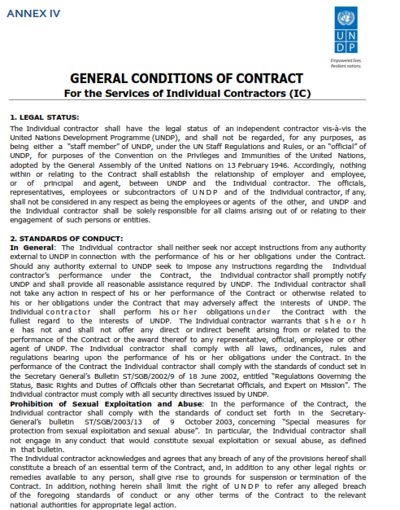
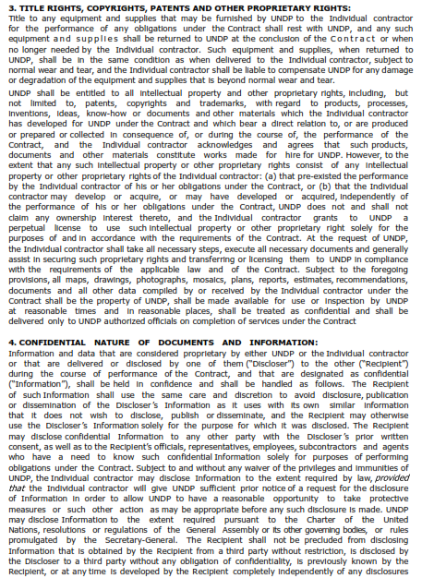
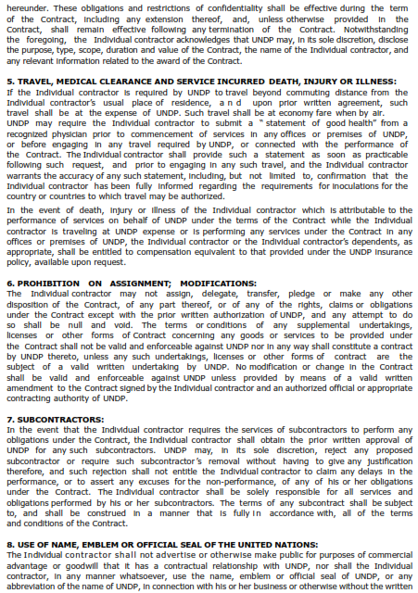
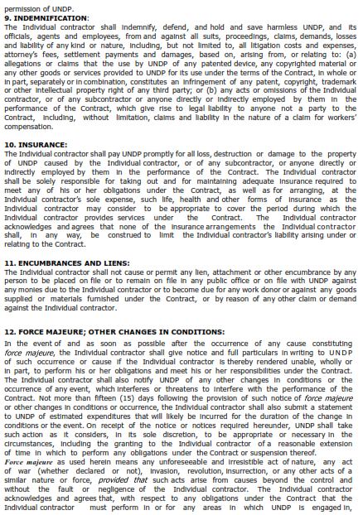

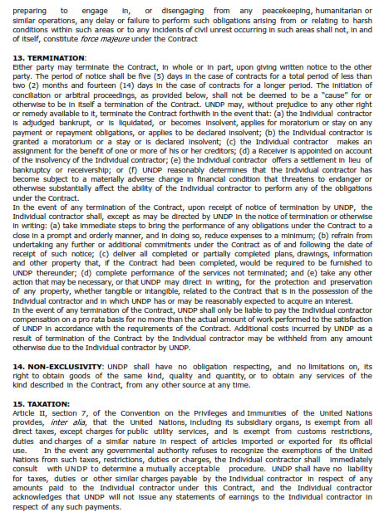
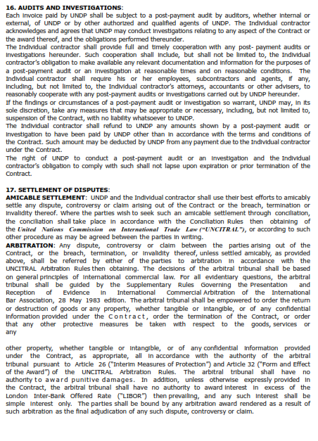
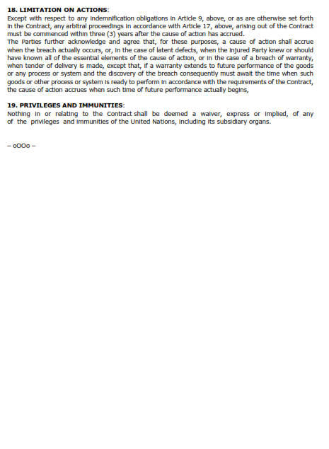

l
The term “All inclusive” implies that all costs (professional fees, travel costs, living allowances, communications, consumables, etc.) that could possibly be incurred by the Contractor are already factored into the final amounts submitted in the proposal
The Financial Proposal Submission Template must be used with No Conditional Statement

